1. Which are the top three variables in your model which contribute most towards the probability of a lead getting converted?

Ans. The top 3 variables in my model are as follows:

-TotalVisits

-The total time spent on the Website.

-Lead Origin_Lead Add Form

2. What are the top 3 categorical/dummy variables in the model which should be focused the most on in order to increase the probability of lead conversion?

Ans. The top 3 categorical/dummy variables are as follows:

- Lead Origin_Lead Add Form

- Lead Source_Olark Chat

- Last Activity_SMS

3. X Education has a period of 2 months every year during which they hire some interns. The sales team has around 10 interns allotted to them. So during this phase, they wish to make the lead conversion more aggressive. So they want almost all of the potential leads (i.e. the customers who have been predicted as 1 by the model) to be converted and hence, want to make phone calls to as much of such people as possible. Suggest a good strategy they should employ at this stage.

Ans.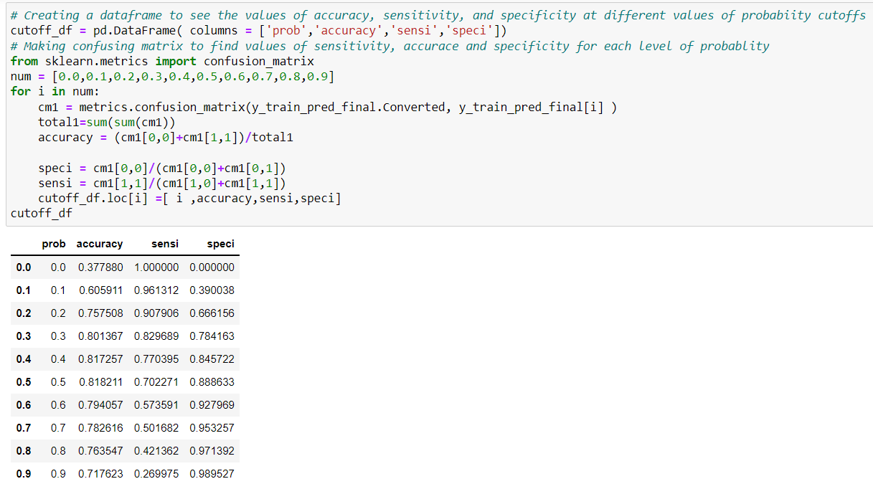  
While getting the optimal cutoff point they get all the potential leads to be converted.

4. Similarly, at times, the company reaches its target for a quarter before the deadline. During this time, the company wants the sales team to focus on some new work as well. So during this time, the company’s aim is to not make phone calls unless it’s extremely necessary, i.e. they want to minimize the rate of useless phone calls. Suggest a strategy they should employ at this stage.

Ans. They need to focus on other methods like automated emails and SMS. And to minimize the rate of useless phone calls they should decrease the cut off in the model. The above strategy can be used but with the customers that have very high chance of buying the course.